Writing Conference Guide Sheet

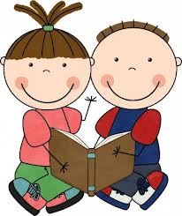
1. Ideas
- I want to hear your story first before we edit it.
Read me your planning sheet.
Next, read me your book.
Did you remember to write all of your details?

- Does your story make sense?

- Does your story have a clear beginning, middle and end?

- Is there any missing information or any places that we can add details?

2. Word Choice and Voice
- Did you use creative, unique WOW words? Could we add more?

- Did you use describing words to make your sentences better? Could we add more?

- Does your writing sound like you? Did you start with a great lead?

- Do your sentences vary in length and start in different ways?

3. Spelling
- Are the class spelling words that appear in your story spelled correctly?

- Are there misspelled words that appear over and over again in your book that we can find?

- I am going to circle a few words on each page for you to look up in your word book. (range of 2-5 depending on student’s abilities)

4. Punctuation and Capitalization
- Have you placed your punctuation correctly?
- Does your punctuation help give meaning to your story?

- Does every sentence start with an uppercase letter?

- Does every name start with an uppercase letter?

- Are there misplaced punctuation marks or capital letters?

